**EstateFlow**

**An Estate Agency Management System**



**Supervisor:** David Kelly

**Module:** Project – Year 2

**Group:** Adam Noonan C00299231

Amelia Hamulequicz C00296605

Darius Herdes C00296548

Mark Lambert C00192497

Contents

User Interface 3

Add Screens 3

Delete Screens 4

Amend/View Screens 5

Report Screens 6

Menus 7

System Layout 8

Database Tables 9

Bid Table 9

Client Table 10

Office Table 11

Property Table 12

Land Table 13

Group Work 14

Menu HTML 14

Menu CSS 15

16

Adam Noonan 17

Amelia Hamulewicz 18

Mark Lambert 19

# User Interface

## Add Screens

(Mark Lambert)

**Layout**

A structured form displayed within a “main content area”, where the form is surrounded by the system’s menu (displayed at the left) and a top bar. The form is centred within the main content area

**Alignment**

The main heading “Add a New ....” is centre aligned. The form is split using field-sets where relevant, with any labels and input fields aligned vertically. So, Property details and any abstract details about a category of property are neatly divided

**Background**

The menu system uses a grey background, the top bar uses a white background while the main content area uses a standard grey background.

**Borders**

Field-sets have a green border, while input fields have a border with a rounded radius. The form has no border, but a dropped shadow to create a 3D effect.

**Logo**

The logo appears at the top of the sidebar, centred. On hover, the logo changes image, providing a dynamically changing logo enhancing user experience

**Font Properties**

The font used is Arial, font size is changed depending on use case. Text appears black in the main content area and white in areas where the background is green.

The main heading appears in a green background with white text.

**HTML Components**

Buttons are green with white text and a rounded border. On hover, the background of the buttons changes to a slightly darker colour. The form buttons are centred at the bottom of the form.

Labels are used to decorate input boxes with useful information for the user. A dropdown list-box is used to select a property owner, populated from the database.

## Delete Screens

(Amelia Hamulewicz)

**Layout**

A form centred within a “main content area”, which is surrounded by a menu system to the left and a top bar displaying the application name.

**Alignment**

The main heading “Delete a ....” is centre aligned. The form is split using field sets where relevant, with any labels and input fields aligned vertically.

**Background**

The menu system uses a grey background, the top bar uses a white background while the main content area uses a standard grey background.

**Borders**

Field sets have a green border, while input fields have a border with a rounded radius. The form has no border, but a dropped shadow to create a 3D effect, which is rounded.

**Font Properties**

The font used is Arial, font size is changed depending on use case. Text appears black in the main content area and white in areas where the background is green.

The main heading appears in a green background with white text, and reflects the page which the user has clicked on.

**HTML Components**

Buttons are green with white text and a rounded border. On hover, the background of the buttons changes to a slightly darker colour. The form buttons are centred at the bottom of the form.

Labels are used to decorate input boxes with useful information for the user. A dropdown list-box is used to select a property, populated from the database.

A pop is displayed to prompt the user for a confirmation upon clicking delete.

## Amend/View Screens

(Adam Noonan)

**Layout**

A form centred within a “main content area”, which is surrounded by a menu system to the left and a top bar displaying the application name.

**Alignment**

The main heading “Amend/View a ....” is centre aligned. The form is split using field sets where relevant, with any labels and input fields aligned vertically.

**Background**

The menu system uses a grey background, the top bar uses a white background while the main content area uses a standard grey background.

**Borders**

Field sets have a green border, while input fields have a border with a rounded radius. The form has no border, but a dropped shadow to create a 3D effect, which is rounded.

**Font Properties**

The font used is Arial, font size is changed depending on use case. Text appears black in the main content area and white in areas where the background is green.

The main heading appears in a green background with white text and reflects the page which the user has clicked on.

**HTML Components**

Buttons are green with white text and a rounded border. On hover, the background of the buttons changes to a slightly darker colour. The form buttons are centred at the bottom of the form.

Labels are used to decorate input boxes with useful information for the user. A dropdown list-box is used to select a property, populated from the database. Fields are initially locked and are unlocked by clicking the “Amend” button located above the form.

A pop is displayed to prompt the user for a confirmation upon clicking delete.

## Report Screens

**Layout**

A report centred within a “main content area”, which is surrounded by a menu system to the left and a top bar displaying the application name.

**Alignment**

The main heading ...Reports” is centre aligned. The report is centred for clear readability.

**Background**

The menu system uses a grey background, the top bar uses a white background while the main content area uses a standard grey background.

**Borders**

Borders for buttons are rounded, while borders for background purposes are straight.

**Font Properties**

The font used is Arial, font size is changed depending on use case. Text appears black in the main content area and white in areas where the background is green.

The main heading appears in a green background with white text and reflects the page which the user has clicked on.

**HTML Components**

Buttons are green with white text and a rounded border. On hover, the background of the buttons changes to a slightly darker colour. The form buttons are centred at the bottom of the form.

## Menus

(Amelia Hamulewicz, Adam Noonan, Mark Lambert)

**Layout**

The menu system is implemented using a sidebar. The logo is displayed large, centred at the top of the menu.

**Alignment**

The side bar is 250px wide, spans the entire height of the window and begins at the very top left of the screen. The top bar is fixed to the top of the screen.

**Background**

The menu system uses a grey background, the top bar uses a white background

**Borders**

Buttons have rounded borders, white the borders for the menu system remain unrounded.

**Font Properties**

The font used is Arial, font size is changed depending on use case. Text appears green, and where a button is selected, the text changes to white on a green background.

“EstateFlow” appears as a heading in green at the top of the page in the top bar.

**HTML Components**

Buttons are white with green text and altered using the .selected class to appear white, or when hovered over.

# System Layout

(Mark Lambert)

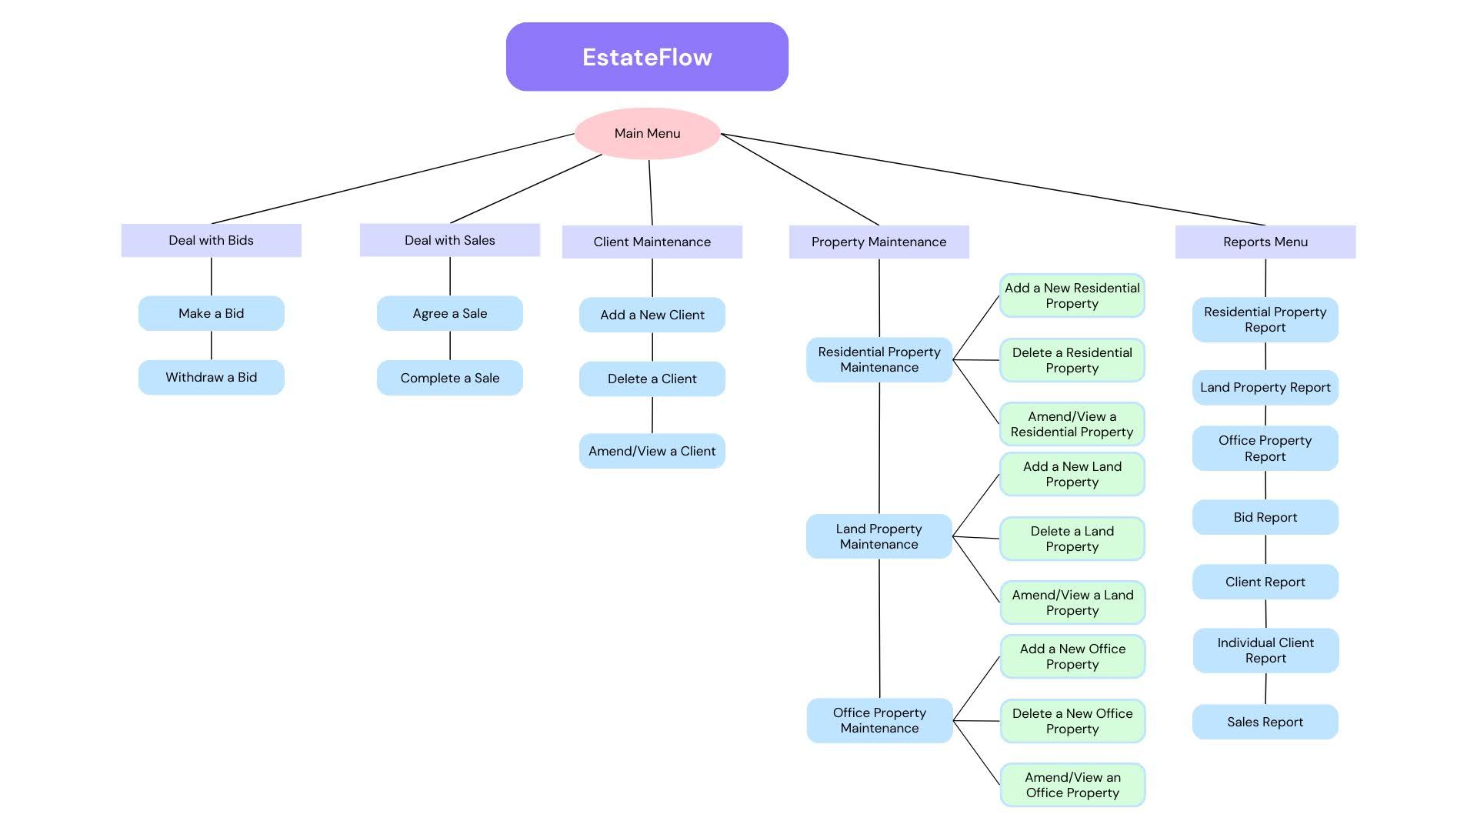

# Database Tables

## Bid Table

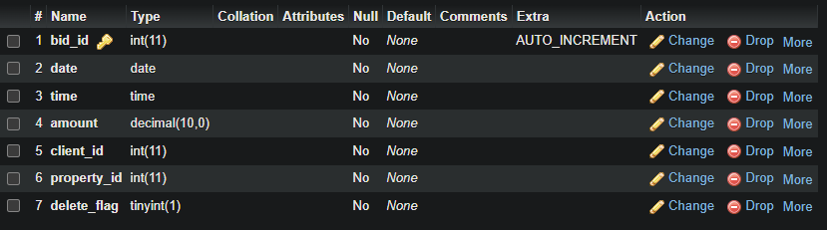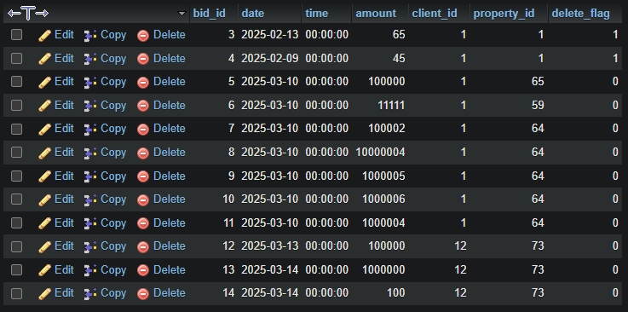(Adam Noonan)

**Bid Table –** Structure

**Bid Table -** Populated

## Client Table

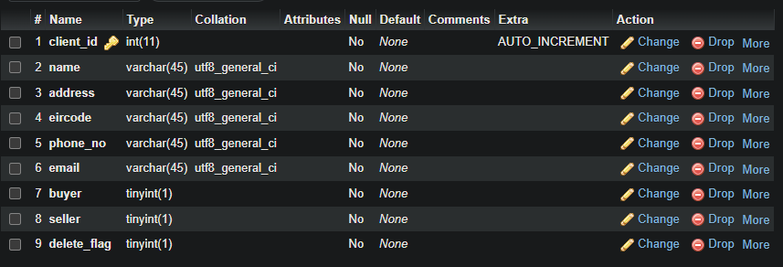(Adam Noonan)

**Client Table -** Structure

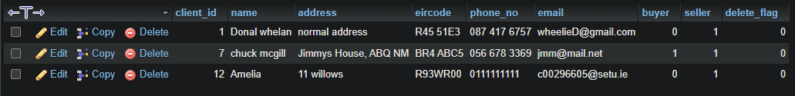**Client Table -** Populated

## Office Table

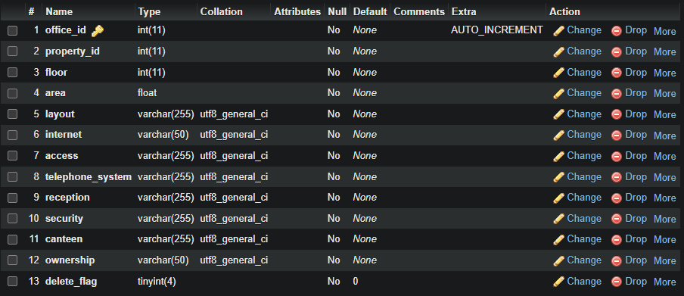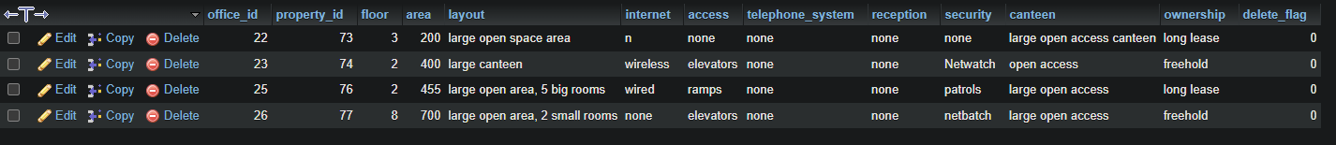(Amelia Hamulewicz)

**Office Table -** Structure

**Client Table -** Populated

## Property Table

(Amelia Hamulewicz)

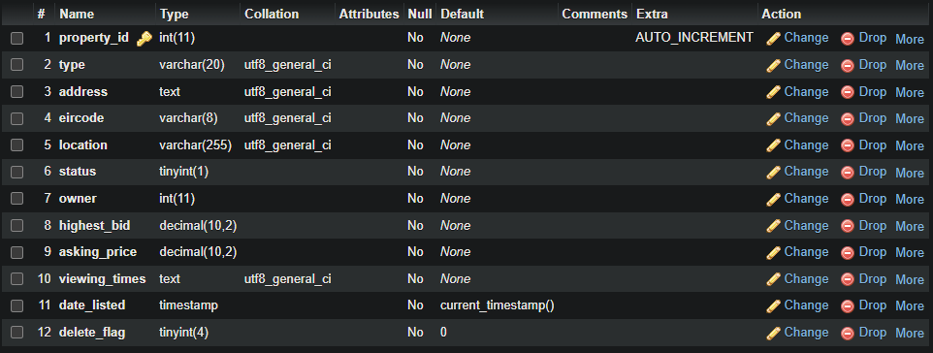**Property Table -** Structure

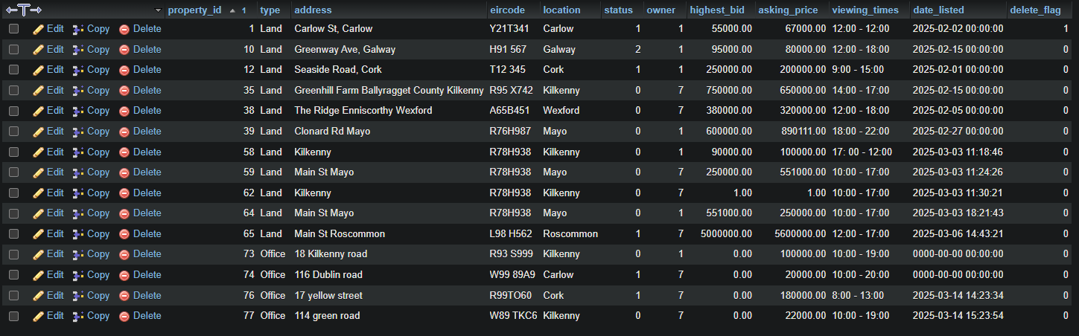**Property Table -** Populated

## Land Table

(Mark Lambert)

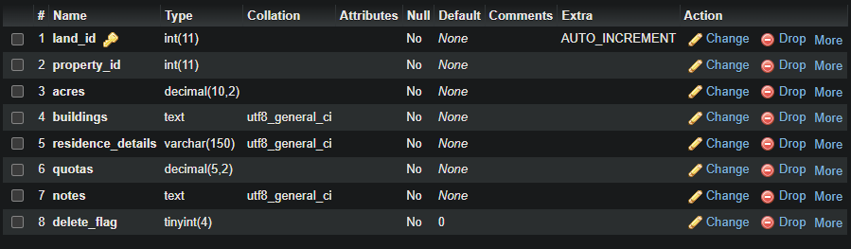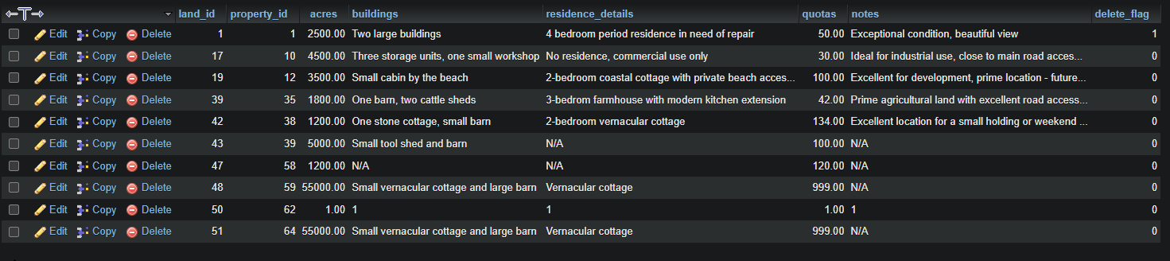**Land Table -** Structure

**Land Table -** Populated

## Staff Table

(Mark Lambert)

**Staff Table -** Structure

**Staff Table -** Populated

## Group Work

**Menu HTML**

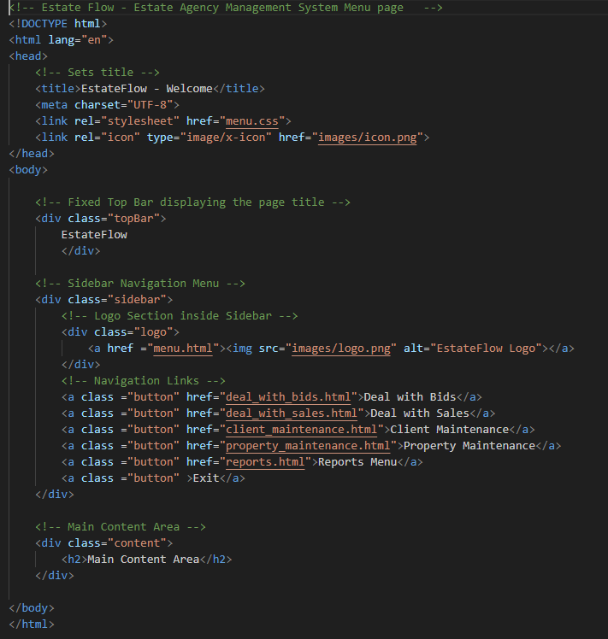

**Menu CSS**

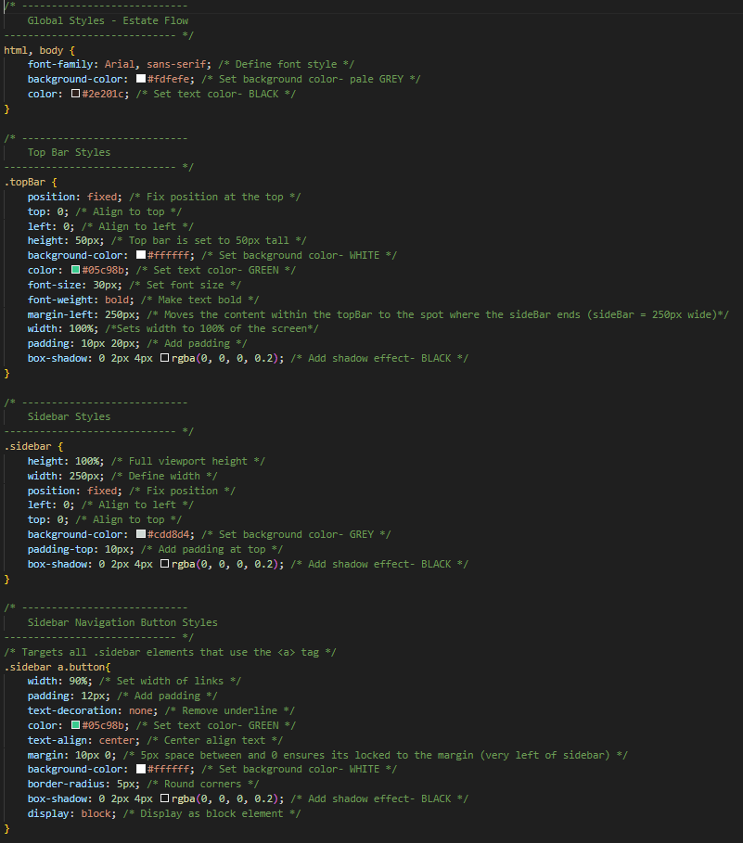

**Menu CSS continued**

## 

# Adam Noonan

# Amelia Hamulewicz

## ER Diagram

**Level 1**

**Level 2**

# Mark Lambert

## Add a New Land Property

**HTML Screenshot**

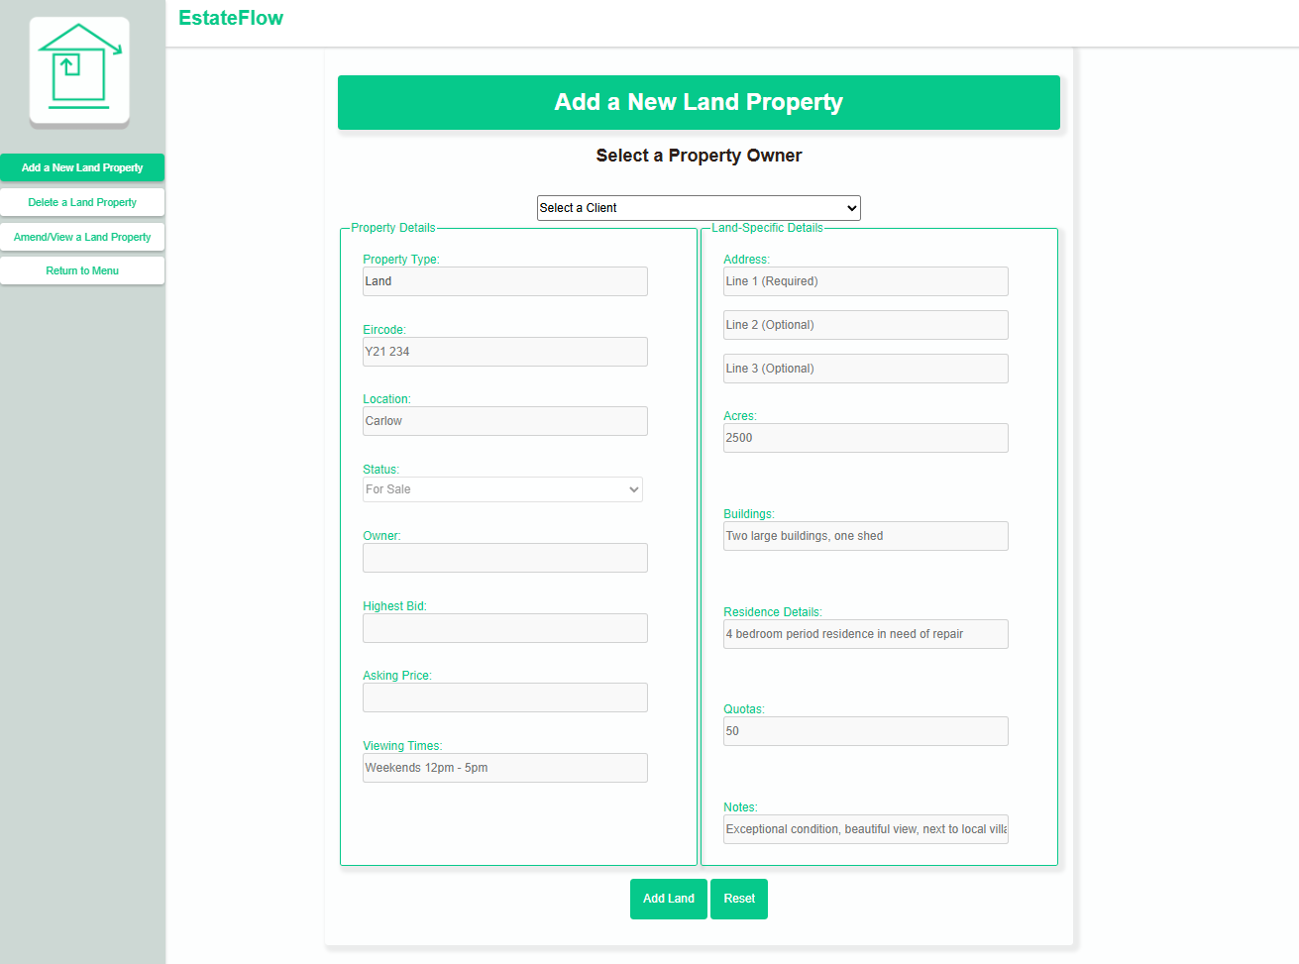

**Code Screenshot**

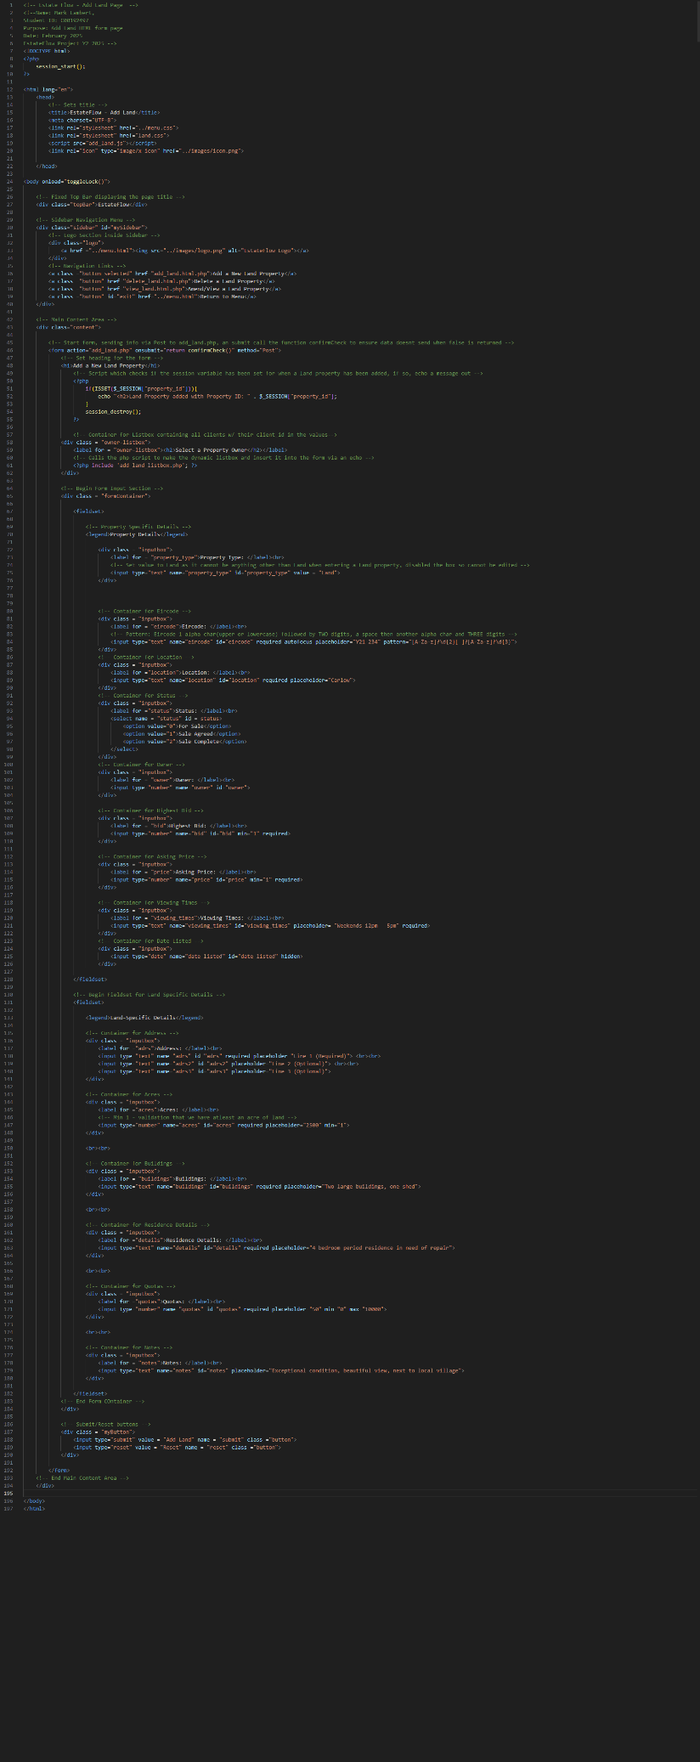

## Delete a Land Property

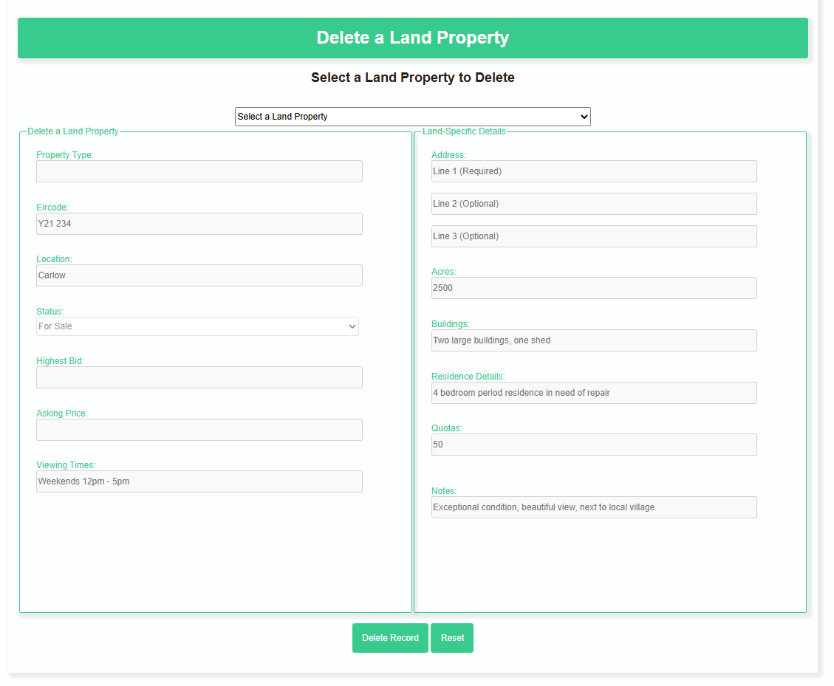**HTML Screenshot**

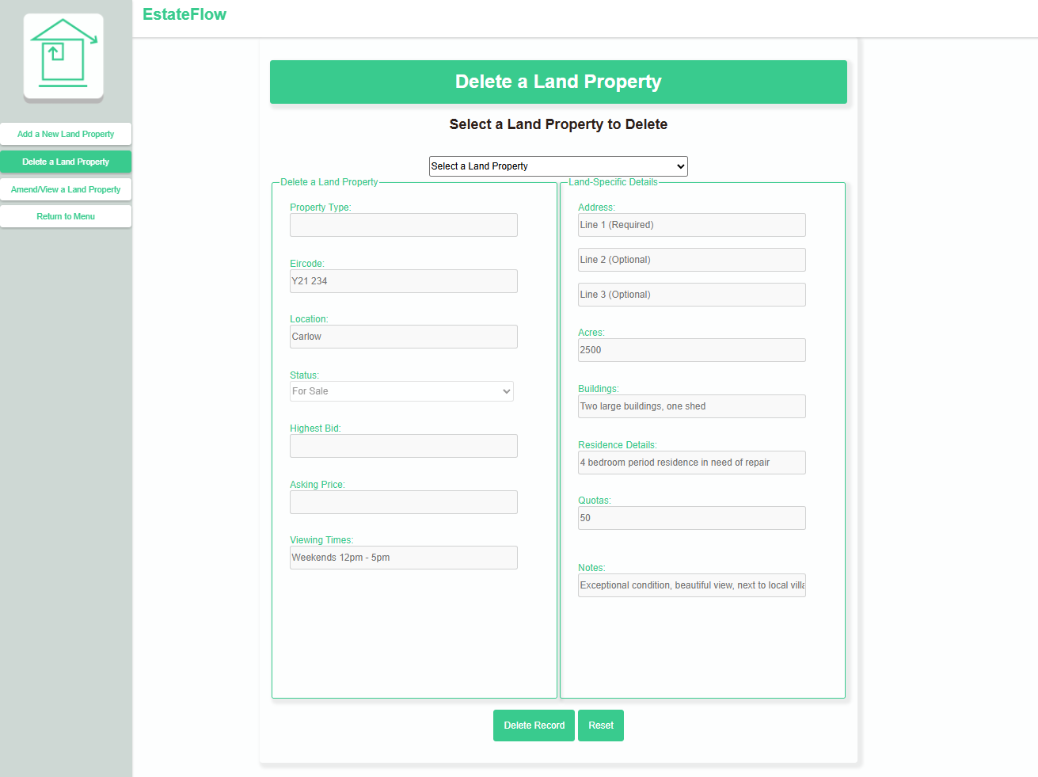

**Code Screenshot**

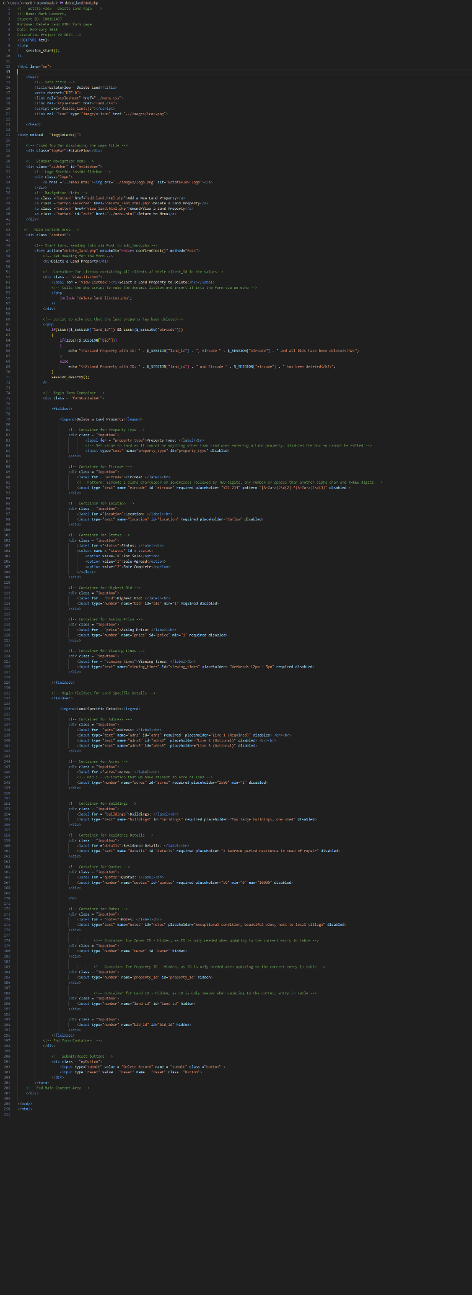

## Amend/View a Land Property

**HTML Screenshot**

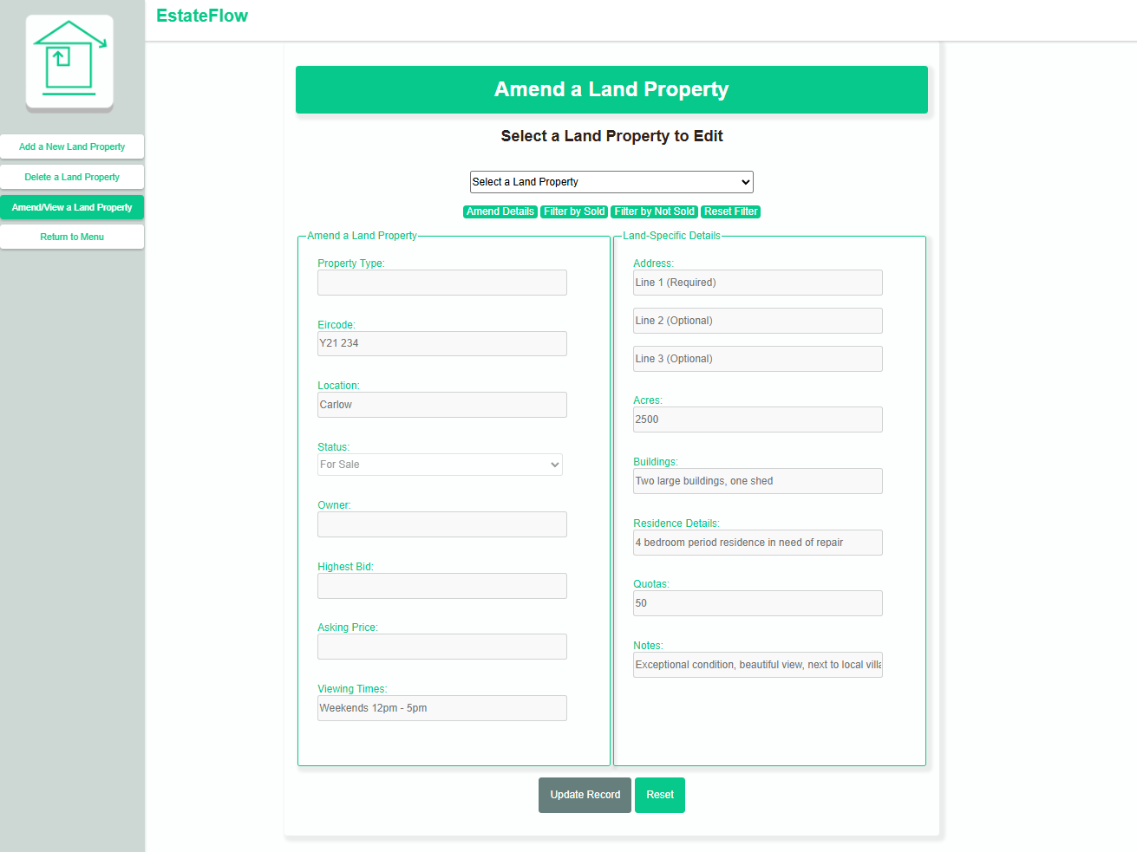

**Code Screenshot**

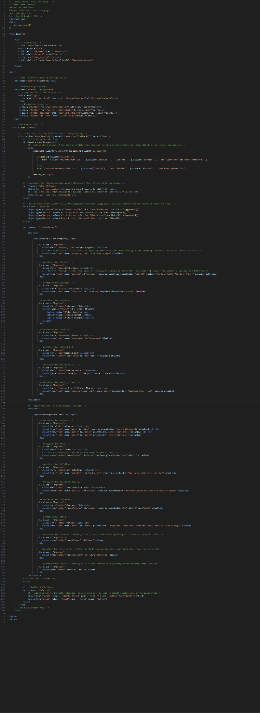

## Land Property Report

**HTML Screenshot**

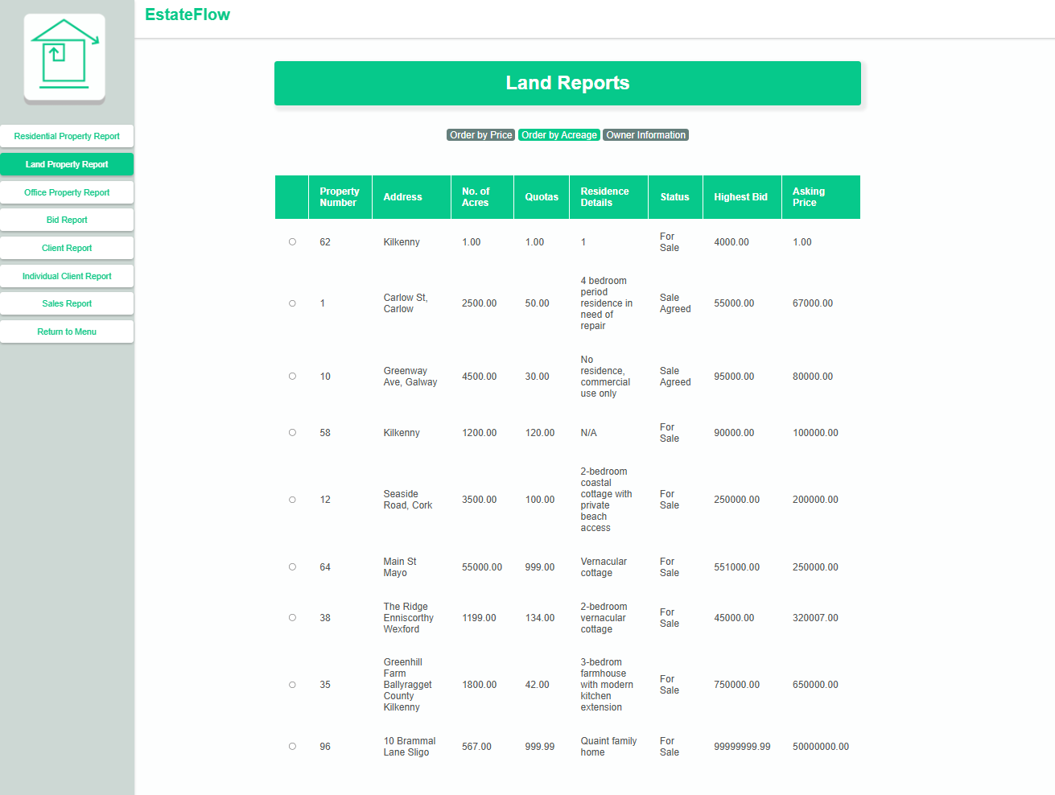

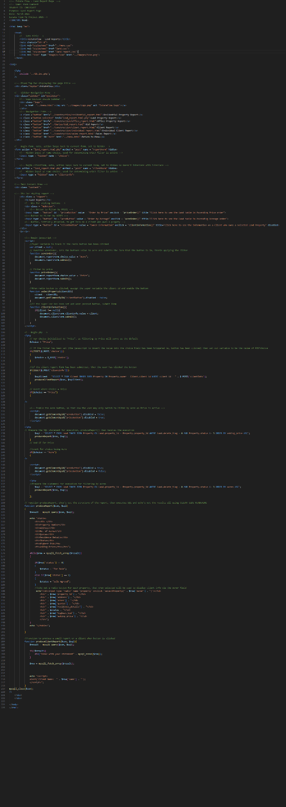**Code Screenshot**